**2019 May Day MCM**

**Problem A: Let the javelin fly**

Javelin throwing is a historic track-and-field event. The distance of javelin throwing is affected by the following 3 factors: level of the athlete (including release speed, release angle, initial attack angle, release height, initial pitch angular speed when release the javelin, etc.); the technical paraments of javelin (including length, weight, geometry, the position of the center of gravity , centroid position , etc.) and the competition environment ( including air density and viscosity, wind, wind direction, etc. ). To make the discussion easier, excluding the precession effect of Javelin during flight, assuming that the athlete’s release height is $2m$, the weight of the javelin is $800g$ the air density is $1.184×{10}^{-3}{g/cm}^{3}$, the air viscosity is $1.84×{10}^{-5}pa∙s$ (Pa · second).

1. The size data of a certain type of Javelin are available now (see appendix). Please estimate the cross-sectional area of ​​the javelin along the center axis, the surface area of ​​the javelin, and the position of the javelin centroid. (See the schematic diagram of the javelin in 【the national standard】GB/ T 22765-2008 - javelin )
2. Here exists testing data of 24 athletes throwing the same javelin in one javelin competition (see appendix), please analyze these data, establish an appropriate mathematical model to find out the law of motion of the javelin flying process.
3. Assume the geometry of a javelin is the same as the problem 1, and the center of gravity is $10cm$ in front of the centroid (the center of gravity is between the tip and the centroid). The initial pitch angle speed is 0 when the javelin is released. Under the premise of no wind, analyze the stress condition and motion of the javelin throw at the moment of release and after release, establish a mathematical model of javelin flight and solve the following questions: (1) Assume the release speed of one athlete is $29.70m/s,$ release angle is ${36.6}^{°}$, initial angle of attack is ${-0.9}^{°}$. Please estimate the javelin throw distance. (2) Assume the release speed of one athlete is $30m/s.$ In order to maximize the throwing distance, please figure out the optimal release angle and initial attack angle and estimated the throwing distance.
4. Assume that the technical parameters of the javelin are the same as the problem 3, the wind direction could be divide into downwind and upwind, and the wind speeds are $3m/s，6m/s, 9m/s$ respectively, the release speed of the athlete is $31.70m/s$. Please establish a mathematical model of the javelin flight, calculate the optimal release angle, the optimal initial angle of attack, the optimal initial pitch angle speed to maximize the throw distance, and fill out Table 1.
5. Assume that the technical parameters of the javelin are the same as the problem 3. Please analyze the relative importance of factors such as release speed, release angle, initial attack angle, initial pitch angle speed, wind direction and wind speed on the javelin throwing distance.

Table 1 Question 4 results

|  |  |  |  |  |  |  |
| --- | --- | --- | --- | --- | --- | --- |
|  | Downwind | | | Upwind | | |
| $$3m/s$$ | $$6m/s$$ | $$9m/s$$ | $$3m/s$$ | $$6m/s$$ | $$9m/s$$ |
| Optimal release angle (angle) |  |  |  |  |  |  |
| Optimal initial attack angle (angle) |  |  |  |  |  |  |
| Optimal initial pitch angle speed (angle/speed) |  |  |  |  |  |  |
| Maximum throwing distance (meter) |  |  |  |  |  |  |

Note:

1. The centroid (also known as the center of area) is the geometric center of the profile graphics along the central axis of the javelin.
2. Angle description: release angle α is the angle between the direction of the javelin release speed and the level ground; initial attack angle β is the angle between the long axis of the javelin and direction of the speed of the javelin when it is released; armed angle γ refers to the angle between long axis of the javelin and the level ground. The initial angle of attack β = the armed angle γ− the initial attack angle α.

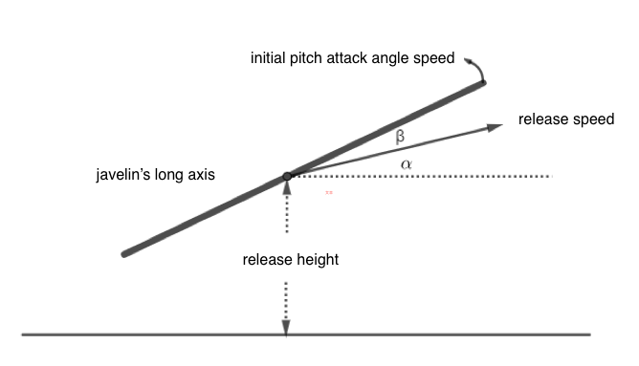

1. The initial pitch angle speed is the moment the javelin shot, the angle of the half axis of the javelin tip (spearhead portion to the center of gravity) rotates around the center of gravity within a unit time(javelin tip half axle rotates counterclockwise, rise up javelin tip ----upward , the initial pitch angle speed is positive; javelin tip half axle rotates clockwise, javelin is bowed --- downward, the initial pitch angle speed is negative). When athlete throw javelin, the direction of the force is deviated from the longitudinal axis of the javelin, hence the javelin tip half axle in up or bow rotation about the center of gravity at the moment of shooting (also known as upward or downward), the degree of rotation could be described by initial pitch angle speed.